Exercises

* Reformat the last code to organize the widgets *horizontally* (Hint: lookup *Row*)
* Reformat the last code to change the background color of the *Scaffold* to **Red**.
* Reformat the last code to change the *AppBar* color to **Red**.
* Reformat the last code to change the start and end colors of the gradient effect (Hint: lookup *begin* and *end* in *LinearGradient*)
* Reformat the last code to create a new widget called *MyButton* that replaces the *ElevatedButton* widget in the code. However, it should accept the *text* as a parameter. Then, use the *MyButton* widget to create two buttons: *Submit* and *Cancel*.
* In Flutter, it is considered a good practice to split the classes into different **.dart** files. Thus, create a new file called *my_app.dart* and move the *MyApp* class to it. Then, import the *my_app.dart* file into the *main.dart* file and fix any errors.

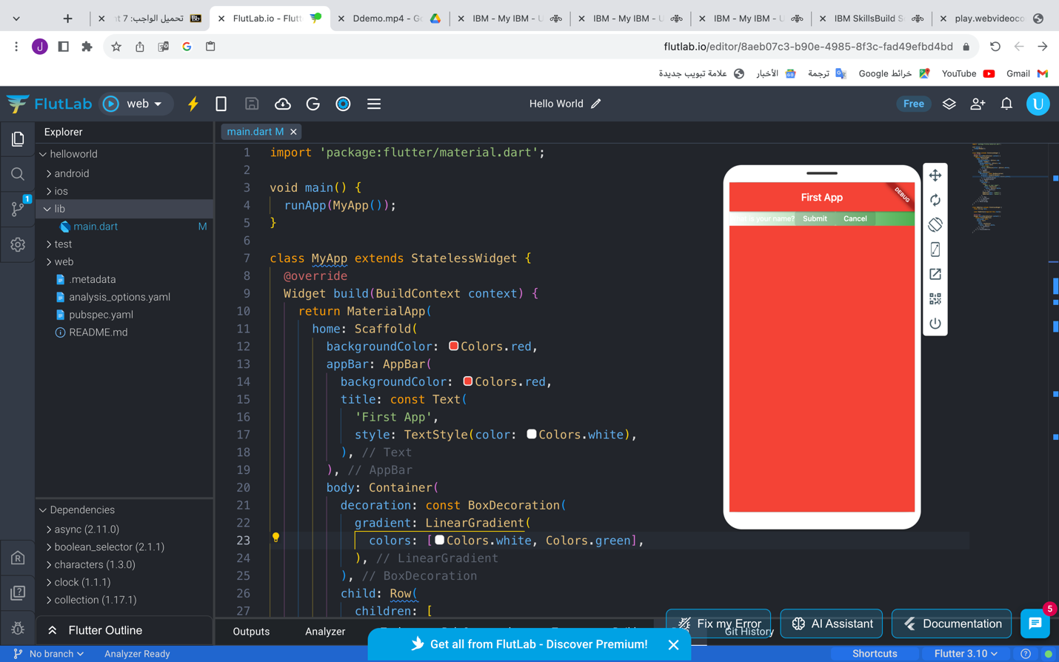

* import 'package:flutter/material.dart';
* void main() {
* runApp(MyApp());
* }
* class MyApp extends StatelessWidget {
* @override
* Widget build(BuildContext context) {
* return MaterialApp(
* home: Scaffold(
* backgroundColor: Colors.red,
* appBar: AppBar(
* backgroundColor: Colors.red,
* title: const Text(
* 'First App',
* style: TextStyle(color: Colors.white),
* ),
* ),
* body: Container(
* decoration: const BoxDecoration(
* gradient: LinearGradient(
* colors: [Colors.white, Colors.green],
* ),
* ),
* child: Row(
* children: [
* Text(
* 'What is your name?',
* style: TextStyle(
* color: Colors.white,
* ),
* ),
* MyButton(text: 'Submit'),
* MyButton(text: 'Cancel'),
* ],
* ),
* ),
* ),
* );
* }
* }
* class MyButton extends StatelessWidget {
* final String text;
* const MyButton({required this.text});
* @override
* Widget build(BuildContext context) {
* return ElevatedButton(
* onPressed: null,
* child: Text(
* text,
* style: TextStyle(
* color: Colors.white,
* ),
* ),
* );
* }
* }
* Write the code to generate the following snapshot

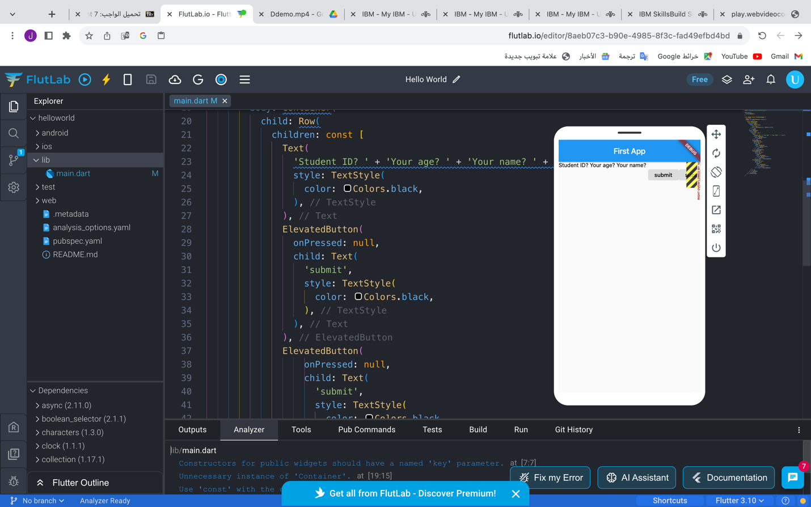

import 'package:flutter/material.dart';

void main() {

runApp(MyApp());

}

class MyApp extends StatelessWidget {

@override

Widget build(BuildContext context) {

// return a widget

return MaterialApp(

home: Scaffold(

appBar: AppBar(

title: const Text(

'First App',

style: TextStyle(color: Colors.white),

),

),

body: Container(

child: Row(

children: const [

Text(

'Student ID? ' + 'Your age? ' + 'Your name? ' + '\n\n\n',

style: TextStyle(

color: Colors.black,

),

),

ElevatedButton(

onPressed: null,

child: Text(

'submit',

style: TextStyle(

color: Colors.black,

),

),

),

ElevatedButton(

onPressed: null,

child: Text(

'submit',

style: TextStyle(

color: Colors.black,

),

)),

ElevatedButton(

onPressed: null,

child: Text(

'submit',

style: TextStyle(

color: Colors.black,

),

))

],

),

),

),

);

}

}